


Release Notes - Version 22.20 SEPTEMBER 2007

1 Overview

Welcome to the latest version of the Aerodynamic Grid and Paneling System. This release has focused on integrating Java3D technology and fusing the link between AGPS and CATIA V5.

Release 22.20 has advanced the CAD Translator Module powered by CadFix OEM™. This allows AGPS to inter-operate with all the other best-known CAD tools, such as, CATIA V4/V5, ProE, UG, etc. without a need for individual licenses to these products. The CAD Translator Module also provides excellent geometry repair and healing utilities.

Calmar Research Corp. also announces the release of the Nemesis3D Grid Interface. A highly automated and interactive grid generation interface – utilizing the VGRIDns toolkits from NASA Langley. Nemesis 3D incorporates the JAVA3D window for a user-friendlier environment.

- Improvements were made to our support of the CGNS file standard.

- Improved ability to move geometry between AGPS and CATIA V5 using the Read-CAD-Data (RCD) and Write-CAD-Data (WCD) commands.
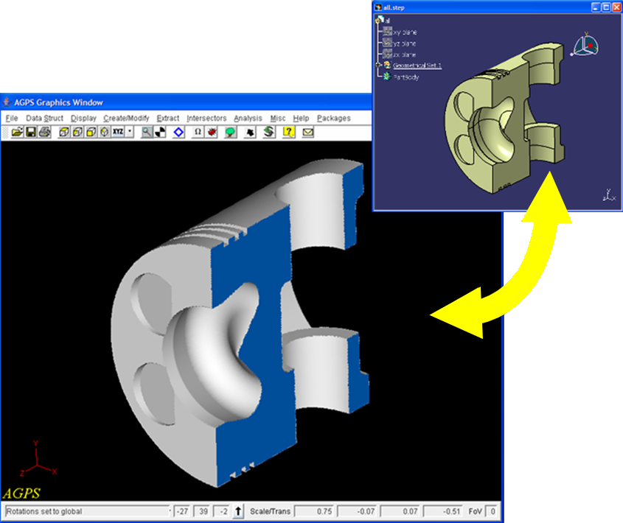

- In addition to input and output of STEP and IGES formats, we support direct input, depending on purchased CAD Translator licenses, of CATIA CATPart files on Windows platforms. (See highlighted image above.)

- Improved support of Java3D. It can be seen in some of our macro library packages.

1.1 Fixes and Changes to AGPS

Approximately 192 changes have been implemented for this release.

2 Command Revisions and Improvements

2.1 List of New Commands

The following commands are new or their status has changed since the previous production release (22.00, November 2006). For details, see Section 3 of the AGPS Reference Manual.

Command | Description | Release Status | Platform Restrictions
D3D | Draw3D | Production | Windows, Linux only  Not available via Exceed
DSP | Display-A-Container | Production | None
RCD | Read-CAD-Data | Production | Windows, Linux only
SUG | Smooth-Unstructured-Grid | Production | None
WCD | Write-CAD-Data | Production | Windows, Linux only
MCG | Manage-CGNS-File | Beta | None
RCG | Read-CGNS-File | Beta | Windows, Linux only
WCG | Write-CGNS-File | Beta | Windows, Linux only

2.1 Updated Commands

The following commands were updated for this release:
Command | Updates
ATL - Add-To-List | Added keyword UNIQUE-ONLY
CBF - Create-Best-Fit | Numerous enhancements, including the ability to fit curves and gridded surface data. Implemented the METHOD-PARAM keyword, which facilitates specification of data parameter values.  Added keywords DIST-SYMBOL, IINDEX, JINDEX, and DEVIATION-POINT.
CLS - Create-List | Added keyword IGNORE-MISSING.
COR - Copy-Object-To-Real | Added keyword TO.
CSC - Create-Surface-Connections | Along with the traditional specification of input surfaces, CSC now allows input of a previously generated Type 39 object.  Added keyword INITIAL-CONNECTION.
D3D - Draw3D | Added the QUALITY keyword, which replaces keywords CONSTANT-S-CURVES and CONSTANT-T-CURVES. Added keyword VIEW.
DEL - Delete | Added keyword FREE-MEMORY.
DIR - Directory | Added keyword FILTER.
DSP - Display-Container | Added keyword OWNER.
ERA - Erase | Added keyword IGNORE-MISSING.
FUS - Fit-Unstructured-Surface | Numerous enhancements added, including:  1. Ability to efficiently screen-pick strings of contiguous USG points (useful for cases with seams).  2. Ability to model cases with collapsed (parametric) edges.  3. Improved corner point handling.
LEG - Create-Mod-Legend | Added keyword TITLE-LEGWINDOW
MCS - Map-Curve-To-Surface | Improved handling of curves with kinks, added warning message if the output curve is out of tolerance.
MUG - Merge-Unstructured-Grids | Added the ability to identify any input grids that were not successfully merged.  Added keywords SELF-ABUTMENTS and UNUSED-GRIDS.
PAU - Pause | Added keywords RESUME and CLEAR-PENDING-ESCAPES.
RFL - Remove-From-List | Added keyword IGNORE-MISSING.
RFT - Refit-To-Tolerance | Numerous enhancements added for handling curves with kinks. Added warnings if the requested tolerance is not met, and the ability to save the points of maximum deviation.  Added keywords MAX-DEVIATION and POINT-OF-MAX-DEVIATION.
RMS - Read-Mult-Strings | Added keyword TRIM-WHITESPACE.
TRP - Triangulate-Points | Added ability to use TRP with nD data where n > 3 (useful for displaying property information for scattered data with P3D).

3 System Directive Revisions and Improvements

The following system directives are introduced with this release. For more details, see section 4 of the AGPS Reference Manual.

Directive | Release Status | Description
D3D_LAYER_INFO | Production | Initial production release.
D3D_LAYER_OPS | Production | Initial production release.
D3D_OBJECT_OPS | Production | Initial production release.
D3D_WINDOW_INFO | Production | Initial production release.
D3D_WINDOW_OPS | Production | Initial production release.
GADGET_LOGGER | Production | Initial production release.
GADGET_REFRESH | Production | Initial production release. Sets the refresh mode for tree gadgets. The default mode refreshes the tree (possibly collapsing it) when the data structure changes. An alternate mode is to update the tree only when the data structure associated with objects shown in the tree change. This alternate mode has the potential to significantly impair AGPS performance.
GADGET_SELECTEDCOLOR | Production | Initial production release. Used to set the color of a selected item of a RadioButton gadget or selected tab of TabbedPane container.
GET_JAVA_PROPERTY | Production | Initial production release.
ON_SELECTION | Production | Initial production release.
SET_BROWSER_DEFAULT | Obsolete

4 Object Type Revisions and Improvements

The following object types/subtypes have been added this release. For more details, see section 2 of the AGPS Reference Manual.

Object (Type/Subtype) | Release Status
Type31CDF - Constant Data Face (Subtype) | Production
Type35 - Unstructured Volume Grid (Type) | Production
Type40VisWindow - Window3D (Subtype) | Production
Type41Logger - Command Logger (Subtype) | Production
Type41ObjectBrowser - Browser | Beta

5 Functions

Functions in AGPS operate in a similar manner to $CALL system directives. The difference is that instead of placing the results in an output parameter, functions return the value in a manner that can be assigned or checked directly from the function call.

The following list includes functions that are new in AGPS 22.00. For details see the AGPS Reference Manual, section 5.

Function | Operation
EXISTS(Object): Boolean | Indicates whether "Object" is a defined object type.
GET_DESCRIPTOR(Object,index): Integer | Returns the descriptor value of the object specified by the integer index value.
GET_NUM_ANCESTORS
GET_PARAMETRIC_DIM(Object): Integer | Returns the parametric dimension of the object.
GET_PHYSICAL_DIM(Object): Integer | Returns the physical dimension of the object.
GET_TYPE(Object): Integer | Returns the numeric representation of the object’s type.
IS_ASSEMBLY(Object): Boolean | Indicates whether the root item of "Object" is a Type 0 Assembly object
IS_CURVE(Object): Boolean | Indicates whether the root item of "Object" is a Curve object.
IS_DRAWN(Object): Boolean | Indicates whether "Object" has been drawn (DRA).
IS_ DRAWN3D
IS_INSIDE
IS_LIST
IS_POINT(Object): Boolean | Indicates whether the root item of "Object" is a point object.
IS_SOLID(Object): Boolean | Indicates whether the root item of "Object" is a solid object.
IS_STRUCTURED_POINTS(Object): Boolean | Indicates whether the root item of "Object" is a structured points object.
IS_SURFACE(Object): Boolean | Indicates whether the root item of "Object" is a surface object.
IS_UNSTRUCTURED_POINTS(Object): Boolean | Indicates whether the root item of "Object" is an unstructured points object.
is_transformed
is_trimmed
contains

6 User Interface

Numerous improvements were made to the graphical user interface (GUI) capabilities. Many of these can be accessed through the CGC, CGG, and DSP commands and associated system directives. The newer packages make extensive use of the latest GUI tools. Some of the significant improvements include:

- ToggleButtons, when pressed, can start a command.

- The object tree and tree gadgets are more user friendly--they do not collapse as frequently.

- The addition of an ObjectBrowser gadget (beta capability, not documented in the Reference Manual)
cgg objectname type=objectbrowser sym=objlist text='filterlist'
where:
- objlist is the returned list of objects selected in the object browser
- filterlist is 1 or many (comma separated) of the following:

Filter Item | Checks For …
ASSEMBLY | assemblies
CONTAINER "CGC" | containers
GADGET "CGG" | gadgets
CSC | type39s
GEOMETRIC | Geometric objects
TRANSFORM | Transformed objects
LIST | Type0
POINT | Point objects
POINTS | Strings, Lattices and ...
CURVE | curves
SURFACE | Surfaces
SOLID | Solids
GRID | Grid objects (structured points)
UNSTRUCTUREDGRID | Unstructured grids
HIDDENNAME | hidden objects (names start with 0)
USERNAME | User named objects

- A command can be run when selecting an object drawn in the AGPS Draw Window using the ON_SELECTION directive.

- When using the locator window to locate points, the last point located can be edited in an editable field.

- The Filebrowser gadget has been enhanced allowing file extensions to be specified in the drop down menu.

- Added an option to reverse the axes on a Plot2D gadget.

- Added a preference to suppress display of cutting plane coefficients in BA and TT modes.

7 IGES and STEP Translation

The legacy IGES and STEP commands (IGE, RIG, and SIG), that use the GEML library, are frozen. The new CADfix-based translation tools in the RCD (Read-CAD-Data) and WCD (Write-CAD-Data) commands have replaced them.

8 Known Problems and Issues

- Java3D commands (involving the Type 40 3D window) will not work through Exceed 9.0.

- Java3D is not available on the HP. We are waiting to receive the latest version from the vendor.

- There are problems with displaying Type 15 Trimmed surfaces using D3D (Java3D window).

- Display of large data sets in a Java3D window can impact mouse gesturing performance in that window. For these instances, set the QUALITY keyword value to "low" or "medium".

- Clicking a PDF hyperlink (such as for Ref Man) from within AGPS may cause your computer to lock up, requiring a shutdown and restart. If it opens at all, it is likely to be as an incomprehensible text file.

- On the HP, the RCD and WCD commands will generally work. They can, however, in certain instances cause exceptions, hangs, and core dumps. We are working on the problem with the CADfix vendor. IGE, RIG, and SIG are still available as backup.

- AGPS may lock up requiring you to kill the session when a real gadget is set out of range and another gadget is clicked prior to entering an in-range value for the real gadget.

- ****************Continuing Issues*******************
On the Linux platform only, fixed-width fonts are not displayed in the Help system. An Arial font is used instead. Fixed-width fonts are used for code segments, where vertical alignment makes the text more readable. This font is also used to create some simple diagrams, such as a depiction of an axis system. If this makes the Help file hard to read, see the AGPS Reference Manual PDF file, which does not have this problem.

- When adding a curve to a PLOT2D gadget, the PLOT2D gadget does not automatically refresh and show the new curve. You must force a refresh using CALL GADGET_UPDATE.

- The GET_MODE OVERFILE keyword cannot be referenced directly (i.e., overfile=[character symbol]).

- When screenpicking, if you have picked at least two objects and then try to pick by dragging a box (Shift + Rightclick and then drag), rubberband lines will be displayed between the previously picked objects, even though rubberband mode is turned off. You can erase the leftover rubberband line(s) in two ways: (1) draw or erase something, or (2) turn rubberband mode on (SET RUBBERBAND) and then off (SET NORUBBERBAND).

- The response to clicking a hyperlink on an online Help page is unpredictable. Links to PDFs within AGPS Help do not work: clicking a link to a PDF will cause your computer to stop functioning. Other links may or may not work. For example, links in the MAI command page go to the top of the page instead of the target page. If a non-PDF link doesn’t work, copy the URL and paste it into the address field of a separate browser window.

Release Notes - Version 22.00 November 2006

1 Overview

Welcome to the latest version of the Aerodynamic Grid and Paneling System. This release has compressed quite a few new Commands, features, and capabilities. This is probably the most exciting release in the AGPS family since the move to JAVA.

Release 22.00 introduces the CAD Translators Module powered by CadFix OEM™. This allows AGPS to inter-operate with all the other best-known CAD tools, such as, CATIA, ProE, UG, etc. without a need for individual licenses to these products. The CAD Translator Module also provides very good geometry repair and healing utilities.

New Boolean operations (Functions) are introduced for placing results in an output parameter. Functions return the value in a manner that can be assigned or checked directly from the function call.
Functions are categorized as math, character, or object functions, depending on their purpose.

Calmar Research also announces the Beta Release of the Nemesis Grid Interface. A highly automated and interactive grid generation interface – utilizing the VGRIDns toolkits from NASA Langley

A New JAVA3D Display Window is available for beta testing.

AGPS 22.00 is also proud to introduce a new License Management scheme, FlexLM™ from Macrovision.

- Support (input, output, storage, and display) has been added for Unstructured Volume grids (beta).

Unstructured Volume Grid
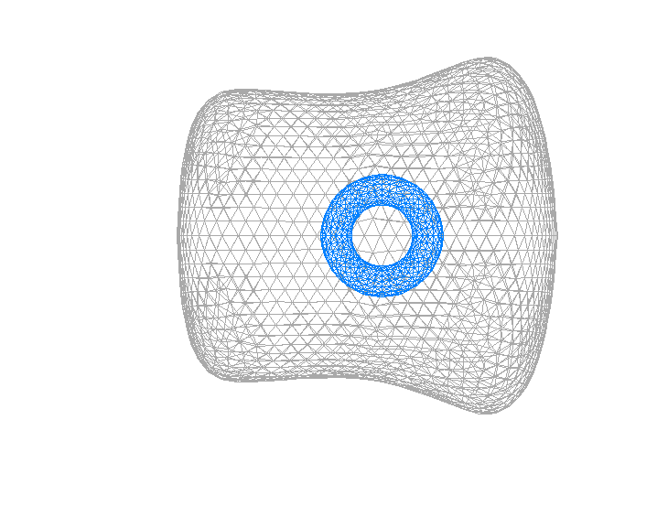

- Support for the CGNS format (RCG, WCG) is introduced.
- New CAD translator commands for IGES, STEP, CATIA, ACIS, etc... files (RCD, WCD) is introduced. See User Interface.

- New character symbol functions (CH_CHANGE, CH_FIND) that use JAVA regular expressions.

- Capability to use alternative mouse cursors (PUT_CURSOR, GET_CURSOR).

- Command history window introduces a "Find" capability added. See User Interface.

- Production quality Rightclick menus are introduced with version 22.00. See User Interface.

- Rubberband lines are introduced with version 22.00. See (SET, SHO commands) and User Interface.

- A method is introduced for stepping though multiple items when in rightclick select mode. See User Interface.

- A new set of AGPS Object Functions is introduced.

- Plot2D gadget plots can now be made from curves as well as strings.

- Symbols, Linestyle, and colors of Plot2D gadget plots can be controlled using Object Properties.

- Numerous GUI (CGC and CGG) sizing and alignment improvements were made, particularly those related to Box containers.

- New D3D (Java 3D drawing command) system directives have been added.

1.1 Fixes and Changes to AGPS

Approximately 192 changes have been implemented for this release.

2 Command Revisions and Improvements

Command | Keyword Change
CMA – CREATE-GUI-CONTAINER | New keywords PARAMETRIC-DIM and PHYSICAL-DIM
LSI/SSI/CSI | Added new keyword, GROUP (YES / NO), default=NO, modifies output list
DSP – DISPLAY-A-CONTAINER | Added new keyword, AUTO-ACTION
ERA – ERASE | Added new keywords, WINDOW and LAYER
FUS – FIT-UNSTRUCTURED-SURFACE | New keywords, SEAM and PERIODIC. PARAMETERS keyword revised
LSP – LEAST-SQUARES-PLANE | Added Point Matrix as a possible POINTS keyword input.
MPT – MODIFY-POINT | New keywords METHOD, LOCATOR-POINT, and DISPLAY-LOCATOR-WINDOW
RUG – READ- UNSTRUCTURED-GRID | New keyword VOLUME-GRID
SET – SET | ATTRIBUTE=RUBBERBAND/NORUBBERBAND, default=NO, turns on/off rubberband.
UGX – UNSTRUCTURED-GRID-EXTRACT | New keywords CUT-SURF and KEEP-REGION. Revised keyword USG-OBJECT.

2.1 List of New Commands

The following list includes commands that are new, or newly implemented. For details, please see the AGPS Reference Manual.

New commands:

- D3D – DRAW3D command draws objects using Java 3D.

- RCD – READ-CAD-DATA command reads CAD data using the CADfix OEM.

- RCG – READ-CGNS-FILE command reads a CFD General Notation System (CGNS) file and creates the appropriate AGPS objects.

- WCD - WRITE-CAD-DATA command writes CAD data using the CADfix OEM.

- WCG – WRITE-CGNS-FILE command writes a 3D Point-Matrix to a CFD General Notation System (CGNS) file.

3 System Directive Revisions and Improvements

The following system directives are introduced with this release. For more details, see section 4 of the AGPS Reference Manual.

- New system directives CH_CHANGE, and CH_FIND, were added in this release to support character system directives. See the AGPS 22.00 Reference Manual for details.

- New system directives D3D_LAYER_INFO, D3D_LAYER_OPS, D3D_WINDOW_INFO, and D3D_WINDOW_OPS, were added in this release to support JAVA3D Display system directives. See the AGPS 22.00 Reference Manual for details.

- New system directives GET_CURSOR, and PUT_CURSOR, were added in this release to support Mouse Cursor system directives. See the AGPS 22.00 Reference Manual for details.

- New system directives GADGET_BROWSERDEFAULT, and GADGET_GETSELECTEDTAB, were added in this release to support the Gadget system directives, particularly Tab and Browser Gadgets. See the AGPS 22.00 Reference Manual for details.

- A New system directive GET_SELECTION_DESCENDANT was added in this release to support the Tree Gadget system directives. See the AGPS 22.00 Reference Manual for details.

- A New system directive PUT_FACEPROPERTIES was added in this release to support the Unstructured Surface Grid Object system directives. See the AGPS 22.00 Reference Manual for details.

- New system directives SCREEN_REFRESH, and, SELECT_IN_TREE were added in this release to support the GUI system directives. See the AGPS 22.00 Reference Manual for details.

In addition, the following system directive is introduced as BETA:

GADGET_LOGGER | Controls action of the logger gadget.

4 Object Type Revisions and Improvements

The following object types/subtypes have been added this release:

- A new Object Type32Iblank (Iblank Point Matrix) has been added that represents iblanking for Structured Grids.

- A new Object Type41Filler (FILLER GADGET) has been added for a box container to control the arrangement of gadgets within the container. It has no inputs or outputs.

- A new Object Type41Plot2D (PLOT2d GADGET) has been added to allow you to display data in an editable 2D plot.

- A new Object Type35 (UNSTRUCTRED VOLUME GRID) has been added to allow you to display volume grids.

5 Functions

The following list includes functions that are new in AGPS 22.00. For details see the AGPS Reference Manual, section 5.

Function | Operation
EXISTS(Object): Boolean | Indicates whether "Object" is a defined object type.
GET_DESCRIPTOR(Object,index): Integer | Returns the descriptor value of the object specified by the integer index value.
GET_PARAMETRIC_DIM(Object): Integer | Returns the parametric dimension of the object.
GET_PHYSICAL_DIM(Object): Integer | Returns the physical dimension of the object.
GET_TYPE(Object): Integer | Returns the numeric representation of the object’s type.
IS_ASSEMBLY(Object): Boolean | Indicates whether the root item of "Object" is a Type 0 Assembly object
IS_CURVE(Object): Boolean | Indicates whether the root item of "Object" is a Curve object.
IS_DRAWN(Object): Boolean | Indicates whether "Object" has been drawn (DRA).
IS_POINT(Object): Boolean | Indicates whether the root item of "Object" is a point object.
IS_SOLID(Object): Boolean | Indicates whether the root item of "Object" is a solid object.
IS_STRUCTURED_POINTS(Object): Boolean | Indicates whether the root item of "Object" is a structured points object.
IS_SURFACE(Object): Boolean | Indicates whether the root item of "Object" is a surface object.
IS_UNSTRUCTURED_POINTS(Object): Boolean | Indicates whether the root item of "Object" is an unstructured points object.

6 User Interface

Rightclick menus are production release with version 22.00. These are pop-up menus that apply to selected objects when you are in Rightclick Selection mode and/or the AGPS Object Tree is open. They are activated with right-button mouse clicks. You may turn on/off this function either through the rightclick_on/_off system directives or through the arrow icon on the AGPS Tool Bar. One difference from the beta version released with version 21.10 is that the RIGHTCLICK_NOMENU directive hides all the menus instead of leaving the Utilities menu. You can create and manipulate your own rightclick menus. See the RIGHTCLICK call routines for details.

When in Rightclick Selection mode and multiple objects are located at the screenpick location, rather than one object arbitrarily being selected with no option to select any of the other objects, now the desired object can be selected by pressing the spacebar to rotate through the possible selections. The message box in the lower left corner of the AGPS graphics window will indicate when multiple objects are at the screenpick location and which object is currently selected.

Rubberband lines are available either through the Preferences dialog or through the SET command. This mode displays rubberband lines between selected, picked, or digitized or located objects and the cursor. Rubberband lines can be observed when rightclick selections are turned on, when screen picking, or when digitizing or locating points on objects. See the documentation for the SET command for more details.

A new AGPS Command Window find capability is introduced with version 22.00. A new menu option, "Find String", is available when right clicking in the command history window. This brings up a "Find" subwindow between the command line and the command history window. A <Ctrl>-F in the command history window also will bring up the "Find" subwindow. See AGPS Operations Notes, section 5.5 for addition details.

7 Known Problems and Issues

- Exceed 9 problems on an XP machine: The text typed into the command line is not visible or the graphics window menus are garbled. If this occurs, do the following:

- Close all Exceed connections.
- Go to the C:\documents and settings\YourUserId\application data\hummingbird\exceed\ directory.
- Delete the file xperf.ini or rename it to something else.
- Restart the Exceed session and start AGPS.

- On the Linux platform only, fixed-width fonts are not displayed in the help system. An Arial font is used instead.

- Fixed-width fonts are used for code segments, where vertical alignment makes the text more readable. This font is also used to create some simple diagrams, such as a depiction of an axis system. If this makes the help file less readable, please refer to the AGPS Reference Manual PDF file, which does not have this problem.

- When running AGPS through Exceed, some AGPS windows move when re-executed/re-displayed, and eventually run off the screen. This is due to Exceed Screen Definition or Display setting. Run the XConfig application (Start -> All Programs -> Hummingbird Connectivity V9.0 -> Exceed -> XConfig), click on the 'Screen Definition' or the 'Display and Video' icon, whichever is displayed. In the 'Advanced Settings' tab, uncheck item 'Configure Window position to Client'. Your Exceed sessions need to be restarted.

- When adding a curve to a PLOT2D gadget, the PLOT2D gadget does not automatically refresh and show the new curve. It is necessary to force a refresh, using CALL GADGET_UPDATE.

- GET_MODE OVERFILE keyword cannot be referenced directly (i.e., overfile=[character symbol]).

- If you are screenpicking and have picked at least two objects, then you try to pick by dragging a box (SHIFT-RIGHTBUTTON drag), you will display rubberband lines between previously-picked objects, even though rubberband mode is turned off. You can erase the leftover rubberband line(s) in two ways: draw or erase something; or set rubberband mode on (SET RUBBERBAND) and then off (SET NORUBBERBAND) again.

- When using the new CH_CHANGE or CH_FIND system directives and the PATTERN argument ends with a double backslash ('\\', which means find a pattern that ends with a single backslash) the pattern must be enclosed within parenthesis (e.g., '(\\)' ) to avoid an error message.

- If the object tree is opened during a session, performance is slowed afterward, even after the object tree has been closed. For lengthy sessions or sessions involving package use, it is better to avoid opening the object tree.

- The response you will get when you click a hyperlink on a page of online Help is unpredictable. We have learned that our links to PDFs simply do not work (your computer is tied up for several minutes as it tries and then fails), but some other links may or may not work as expected. Often, such as with the links in the page for the MAI command, instead of seeing the expected link, your view just pops up to the top of the page on which you found the link. Unless the target is a PDF, go ahead and click the link, then if it doesn’t work, copy the URL and paste it into the address field of a separate web window.

Future Plans

- SGI platform frozen with this release.

- Additional CGNS capability.

- New IGES and STEP translation based on the CADfix product to replace the current GEML-based code.

- Improved CLO algorithm.

- Support for b-rep solids.

Release Notes - Version 21.00

1 Overview

Welcome to the latest version of the Aerodynamic Grid and Paneling System. Release 21.00 introduces the system to the Unstructured Grid world and integrated development environment (IDE) level GUI’s known as Gadgets.
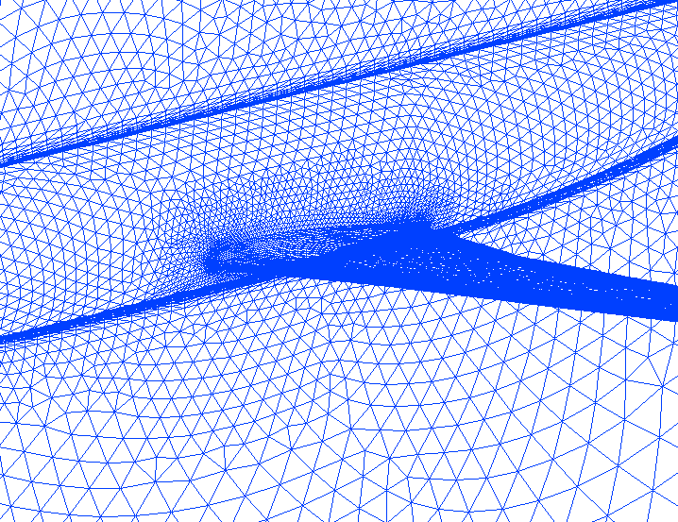
Sample Unstructured Surface Grid.

- Release 21.00 introduces support for the Windows XP and Linux 64-bit operating systems.

- Right-click menus have been added, enabling users to directly manipulate the geometry using the mouse.

- The new RST (RESET) command will reset AGPS data structure and symbols to their conditions at the start of a session.

- A command file has been added to read STEP files in the Utility Library.

1.1 Fixes and Changes to AGPS

- EGS – ELLIPTIC-GRID-SMOOTHER command performs elliptic smoothing on either physical x,y,z points or Subrange points on a surface producing an array of smoothed points in physical 3D space. It now supports all Surface Types.

2 Command Revisions and Improvements

Command | Keyword Change
CGC – CREATE-GUI-CONTAINER | New value VISWINDOW added to keyword TYPE.
CHT – CHORD-HEIGHT-TOLERANCE | Added new keywords FIRST-STEP and LAST-STEP.
CSC – CREATE-SURFACE-CONNECTIONS | Added new keyword, RELATIVE-TOLERANCE and the new default to KISSING-INTERSECTIONS is YES
ECD – EXTRACT-CURVE-DATA | Added new keyword, KINK-ANGLE-TOL .
EOJ/EXI/QUI/STOP | New keyword, TEXT
EVL – EVALUATE | New keyword INFO
FCV – FIT-CURVE | New keyword B-SPLINE-DEGREE
GRT – GRID-TO-TOLERANCE | New keywords RULE and JUMP-REFINEMENT
MPT – MODIFY-POINT | New keyword DIGITIZE-EACH-OBJECT

2.1 List of New Commands

The following list includes commands that are new, or newly implemented. For details, please see the AGPS Reference Manual.

New commands:

- CMA – CREATE-MODIFY-ASSEMBLY command creates an assembly of AGPS objects or an empty assembly. An assembly is a sub-type of a Type 0 List.

- FUS – FIT-UNSTRUCTURED-SURFACE command fits a parametric surface to an unstructured grid of points.

- MP2 - MODIFY-POINT-2 command interactively modifies points. Best used as a means of graphically repositioning points.

- MUG - MERGE-UNSTRUCTURED-GRID command merges two or more surface grids into one composite unstructured surface grid.

- RST - RESET-AGPS command resets the AGPS data structure.

3 System Directive Revisions and Improvements

- New system directives RIGHTCLICK_ATTACH, RIGHTCLICK_CREATE, RIGHTCLICK_DELETE, RIGHTCLICK_EXISTS, RIGHTCLICK_FAMILY, RIGHTCLICK_MODIFY, RIGHTCLICK_NOMENU, RIGHTCLICK_OFF, RIGHTCLICK_ON, CALL RIGHTCLICK_PROPERTIES, RIGHTCLICK_SELECTIONS, and CALL PUT_FILTER were added in this release to support the Right-Click Menu features. See the AGPS 21.00 Reference Manual for details.

In addition, the following system directive has been modified:

CALL GET_MODE | • Various new modes have been added (see AGPS Reference Manual for details),  • Mode names can be used as an argument to return a value. e.g. CALL GET_MODE(VERSION=ver)

4 Object Type Revisions and Improvements

A new Object Type34 (UNSTRUCTURED SURFACE GRID) has been added that represents an unstructured surface grid an unordered set of vertices (surface points) connected to one another to form edges of polygonal faces. Usually the faces are all triangles, but they can have any number of sides, or they can be mixed (e.g., some triangles, and some quadrilaterals.).

A new Object Type46 (UNSTRUCTURED SURFACE) has been added that represents the surface built as an interpolant to a Type 34 Unstructured Surface Grid.

Type2 (COMPOSITE) Object has been modified to include a new descriptor (icre) to store Curve Method used for creation.

5 User Interface

The AGPS Tool Bar has a new look for version 21.00 and offers some new features, such as right-click menus, to enhance the user interface. Please see the AGPS Operations Notes for more information.
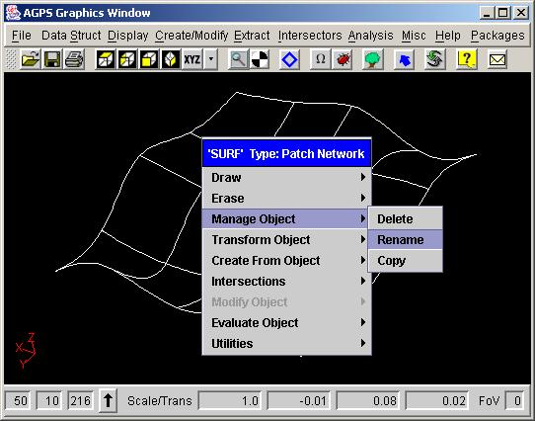

More control of the mouse gain has been added. The mouse gesturing rotation rate is now controllable via the keyboard as follows:
<Ctrl+PageDown>: Decrease rate by factor of two.
<Ctrl+Shft+PageDown>: Decrease rate by a factor of 16.
<Ctrl+PageUp>: Increase rate by factor of two.
<Ctrl+Shft+PageDown>: Increase rate by a factor of 16.
<Ctrl+Home>: Restore default rate of unity.

Use of any of these key combinations will cause the current rotation rate factor to be displayed in the Graphics Window Message Box (lower left-hand corner of Graphics Window). The upper rate limit is set to 2**(4); the lower limit is 2**(-1074).

The following are menu picks used as a front end for I/O functions: EXP (EXPORT) / IMP (IMPORT)
The following are menu picks used as a front end for OFP functions: PGE (PAGE-SETUP) / PRT (PRINT)

6 Known Problems and Issues

- AGPS will not accept keyboard input on SGI platform if the NUMLOCK is on. We have communicated the problem to SGI. Until a fix is received, be sure NUMLOCK is off before starting AGPS.

- Badly formatted Tecplot files that read correctly in the previous version might not read correctly in this version.

- There is a minor issue with translations and rotations interacting in the Graphics window.

- In CGG, the Dimension and Range keywords are switched internal to the code. Contact us for a workaround.

- CSC might be noticeably slower in this version than in previous ones. It's also more reliable.

- Hyperlinks (e.g. More Information) embedded in the online Help files are not working.

Release Notes - Version 20.00

1 Overview

Welcome to the latest version of the Aero-Grid and Paneling System. Release 20.00 comes only six months after AGPS 19.10 (see Release Notes for 19.10) and includes quite a few enhancements and changes.

- AGPS Version 20.00 introduces the platform to the Linux Redhat 8.0 operating system.
- This release introduces a custom toolbar, which allows you to create your own floating toolbars.
- The capability to handle trimmed surfaces has been enhanced.
- The ability to construct and write unstructured grids (the read ability was introduced in version 19.10) has been added.
- The REN and DEL commands have an additional keyword, IGNORE-MISSING, that allows the commands to be used on non-existent objects with no errors reported.
- The new Ellipse (ELL) command will create an ellipse in standard position.
- Fit-Curve-Constrained (FCC) can now create 3D curves as well as 2D. See section III.2 for details.
- Type 39 Surface-Connection objects created by the new CSC command (see Section III.2) can be drawn by a command file called csc_draw.com in the Utility Library, Analysis/Display menu. It can also be called directly, as in GEOMCOM:csc_draw.com.
- Command-line arguments for AGPS startup from a prompt (i.e., Unix/Linux shells) can now be entered in any order. You can also use a new -h argument to display all the arguments.
- The N3D reader and writer in the Utility Library have been enhanced to read and preserve user-defined names and write out numbers with more robust formatting.
- Object Branding is introduced in this release. Object Branding allows you to classify various types of objects into certain brands without affecting the data structure and the object's descriptors and other data. The new system directives PUT_BRAND, CLEAR_BRAND, and GET_BRAND were added in this release to support the Object Branding features.
- Display objects (Type 31 Polynomial--created by SHA command) now support image mapping. You can supply an image file (e.g., mypic.gif) in place of a color for a shaded object. For more information, consult the SHA and Type 31 documentation in the AGPS Reference Manual.
- The Package menu is now ordered alphabetically.

1.1 Fixes and Changes to AGPS

- The default degree for curve/surface/solid fitting routines (e.g., in FCV, BLC, etc.) has been changed from CUBIC to QUINTIC. Quintic fits result in objects that convert to preferred entities in CATIA V5.

- Command-line arguments for AGPS startup from a prompt (i.e., Unix/Linux shells) can now be entered in any order. Now, for instance, the following two commands will launch a session of AGPS in TT mode and run the command file, file.com:

agps tt -i file.com will do the same thing as typing: agps -i file.com tt

- To display all the AGPS command-line startup options, use the -h argument, as in:

agps -h

- The following commands were enhanced to handle trimmed surfaces (Type 15):

CLO, FAR, LSI, LIM, ARE, CSI

- AGPS now has the capability to intersect trimmed surfaces with other surfaces.

- The COLOR keywords used in commands like SHA (COLOR and BACKGROUND-COLOR) now support more options, like the COLOR keyword for DRA. See the version 20.00 AGPS Reference Manual for details.

- When accessing UNIX files or directories from a PC, you must specify the location by using the drive letter followed by a colon and a slash (or backslash). Previously, the slash or backslash was optional. Specifically, you must enter T:/mydirectory in order to access "mydirectory" on the UNIX machine.

- Completed the port of EXR to Java.

- Fixed the restoration of a binary save file from Classic with integer VDS’s in it.

- Fixed problem with ENR command.

- Quality of shaded images with EXE corrected.

2 Command Revisions and Improvements

- EXR - EXECUTE-RAY-TRACING command has been implemented and fine-tuned for better performance. EXR now supports:

- Infinite and point light sources - as many of each as you want.
- Shadows
- Transparent surfaces
- Anti-aliasing

- REN – RENAME, IGNORE-MISSING keyword. The default is NO, which acts as the command has before, i.e., if an OLD-NAME object doesn't exist, then an error message is issued. If IGNORE-MISSING=YES, then all existing objects are renamed, and no error is issued for those that don't exist.

- DEL – DELETE, has the IGNORE-MISSING keyword, which acts the same as it does for REN.

- ELL - ELLIPSE is a new command that creates an ellipse in standard position.

- EXE – EXECUTE-RAY-TRACING, ERASE keyword initial value has been changed from NO to YES.

- CTX – CREATE-TEXT, new keyword UNDERSCORE. If UNDERSCORE=NO (default), underscores in text-string are treated as spaces. If UNDERSCORE=YES, the underscores in text-string are treated as underscores.

- PUR – PURGE, new keyword FREE-MEMORY. If FREE-MEMORY=YES, all available virtual memory is released, making it possible to process bigger jobs. It comes with a performance cost taking much longer than if the keyword is set to NO. FREE-MEMORY=NO (default) will work like PUR has before--cleaning up the data structure, but not freeing virtual memory.

- ECD – EXTRACT-CURVE-DATA, new keyword PT-MATRIX-RESULT. If PT-MATRIX-RESULT=YES, the output will be a Type 33 object for keyword STRING-ID. If PT-MATRIX-RESULT=NO (default), the output will be a Type 9 object for keyword STRING-ID.

- FCC – FIT-CURVE-CONSTRAINED, new keyword DIMENSION=2 (default) creates a 2D curve. DIMENSION=3 creates a 3D curve with a zero value for the z dimension.

- CBF - Create Best Fit (beta) is available in limited form on the SGI platform. The existing Reference Manual write-up for CBF generally applies, but with the following restrictions:

ARRAY-PM-STRING must be a String of 3D points

NUM-PARAMS must be 2 (i.e., only surfaces are allowed

DEGREE must be CUBIC-B-SPLINE

KNOTS must be blank or 2 Strings of 1D points (full knot-multiplicity must be supplied, e.g., [(0),(0),(0),(0),(.5),(1),(1),(1),(1)] defines a cubic spline knot String with one internal knot)

METHOD-PARAM must be blank

PARAMETERS must be 2 Strings of 1D points

BOUNDARIES must be blank

RMS-ERROR must be NO

- CSC - Create-Surface-Connections is a new command that creates a new Type 39 Surface-Connection object based on a collection of one or more specified surfaces. Once constructed, this object contains lists of relevant connectivity information associated with the input surface objects. In particular, each surface edge (or portion thereof, called an edge segment) will have its neighboring surface edge segments, if any, defined and identified. See the Type 39 object type description for the data structure details.

- SAN - SOLID-ANGLE command is obsolete.

- CBC - READ-BICUBIC-FILE command is obsolete.

- HEL - Help now supports HTML files.

2.1 List of New Commands

The following list includes commands that are new, or newly implemented. For details, please see the AGPS Reference Manual.

New commands:

- CSC - CREATE-SURFACE-CONNECTIONS
- ELL - ELLIPSE
- SIG - STEP/IGES/GEML-UTILITIES
- USG - GENERATE-UNSTRUCTURED-GRID
- WUG - WRITE-UNSTRUCTURED-GRID
- EXR - EXECUTE-RAY-TRACING
- MAG - MINIMUM-AREA-GRID

3 System Directive Revisions and Improvements

- Multiple sets of radio buttons can be used in a single menu-mixture construct. See the AGPS 20.00 Reference Manual for details.

- New system directives PUT_BRAND, CLEAR_BRAND, and GET_BRAND were added in this release to support the Object Branding features. See the AGPS 20.00 Reference Manual for details.

- A Custom Tool Bar provides a component that you can create and display just like the other permanent components in the AGPS graphical user interface. See the AGPS 20.00 Reference Manual for details.

4 Object Type Revisions and Improvements

A new Object Type39 (SURFACE-CONNECTIONS) has been added that represents the connections (adjacencies) among a collection of AGPS surfaces.

5 Menu Changes

Please see section III.2 for details on changes to commands.

Command | Keyword Change
RP3 - READ PLOT3D | Keyword: GRID-NUMBER default is now ALL instead of 1
BLC, FCV, FSO, FSU, RFT, SBP, STN | DEGREE initial default changed from CUBIC to QUINTIC
STC | BLENDING initial default changed from CUBIC to QUINTIC
EXR | (multiple light sources - no limits)
REN, DEL | New keyword, IGNORE-MISSING
EXE | Keyword ERASE initial value changed from NO to YES
CTX | Added keyword UNDERSCORE
PUR | Added keyword FREE-MEMORY.
RPO | Added QUINTIC to S-param, T-param radio button option
ECD | Added keyword PT-MATRIX -RESULT
FCC | Added keyword DIMENSION

6 Known Problems and Issues

- AGPS will not accept keyboard input on SGI platform if the NUMLOCK is on. We have communicated the problem to SGI. Until a fix is received, be sure NUMLOCK is off before starting AGPS.

- If you are an SGI user you may be accustomed to setting your window placement interactively through the IRIS Extended Motif X Window Manager (4Dwm), typically through a line in your ".Xdefaults" file: 4Dwm*interactivePlacement: True. This option will not work in version 20.00. AGPS will always size and place your windows according to the "preferred" location, which is either the default or stored in a file you create with SET WWG. Help will not display properly when in TT mode and no Unix DISPLAY variable is set. To get help to display, set your DISPLAY environment variable to the proper location.

- When you try to "more" a file on Linux with CXP and then try to get the output from the "more" with TXP, no output ever becomes available and the process does not terminate (i.e. it hangs with a status of "-1" with a TXP NEXT command). The good news is that "less" is "more". If you change the "more" to "less" in either case, you get the expected output. You can also get the expected output with "cat". With the "eto", if you just enter "eto" and then do a "more" in the new window, the "more" works as expected.

- The UPDATE and DONE buttons of the Color Chooser, invoked by the RAS command, appear to do nothing. The color is actually changed, but the display does not refresh. You need to redraw the object to see the new color.

- Running on Unix or Linux platforms in VS mode, directly invoking an arbitrary text file via the HELP command (e.g., HEL MYFILE.DAT) does not recognize line breaks. This was an unintentional side effect of the change to the system that allows it to read HTML files. HTML files are NOT displayed properly if accessed via the AGPS command line (i.e. HEL samplefile.html).

